1. **Delivery Time:**

df <- read.csv("delivery_time.csv")  
View(df)  
library('lattice')

#EDA  
boxplot(df$Sorting.Time)  
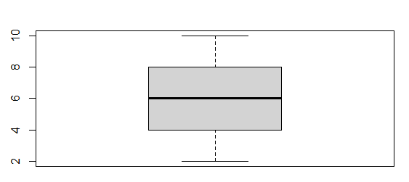  
boxplot(df$Delivery.Time)  
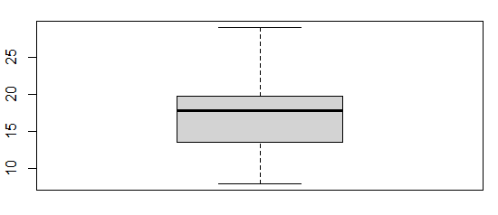  
plot(df$Sorting.Time, df$Delivery.Time, main = "Scatter Plot")  
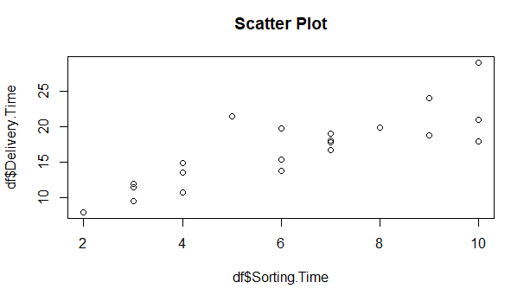

#Linear Regression Model  
model <- lm(Delivery.Time~Sorting.Time, data=df)  
summary(model)

Call:  
lm(formula = df$Delivery.Time ~ df$Sorting.Time)

Residuals:  
 Min 1Q Median 3Q Max   
-5.1729 -2.0298 -0.0298 0.8741 6.6722

Coefficients:  
 Estimate Std. Error t value Pr(>|t|)   
(Intercept) 6.5827 1.7217 3.823 0.00115 **   
df$Sorting.Time 1.6490 0.2582 6.387 3.98e-06 ***  
---  
Signif. codes: 0 ‘***’ 0.001 ‘**’ 0.01 ‘*’ 0.05 ‘.’ 0.1 ‘ ’ 1

Residual standard error: 2.935 on 19 degrees of freedom  
Multiple R-squared: 0.6823, Adjusted R-squared: 0.6655   
F-statistic: 40.8 on 1 and 19 DF, p-value: 3.983e-06

**#Prediction  
>predict(model, data.frame(Sorting.Time=c(10,9,8,7,6,5,4)))**

**1 2 3 4 5 6 7**

**23.07293 21.42391 19.77489 18.12587 16.47685 14.82783 13.17881**

1. **Salary Hike:**

df <- read.csv("Salary_Data.csv")  
View(df)

#EDA  
boxplot(df$YearsExperience)  
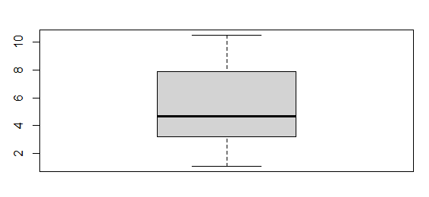

boxplot(df$Salary)  
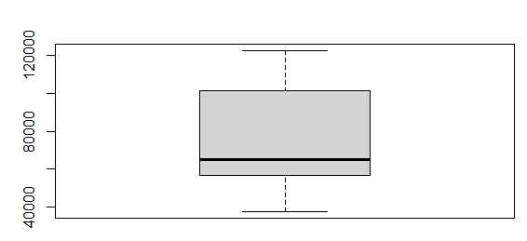  
plot(df$YearsExperience, df$Salary, main="Scatter Plot")  
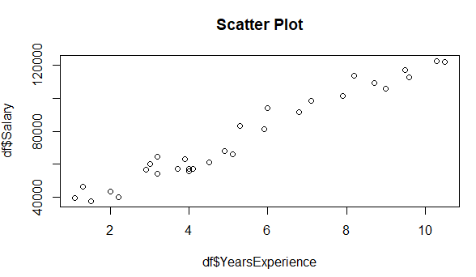

#Linear Regression Model  
model <- lm(Salary~YearsExperience, data=df)  
summary(model)  
Call:  
lm(formula = Salary ~ YearsExperience, data = df)

Residuals:  
 Min 1Q Median 3Q Max   
-7958.0 -4088.5 -459.9 3372.6 11448.0

Coefficients:  
 Estimate Std. Error t value Pr(>|t|)   
(Intercept) 25792.2 2273.1 11.35 5.51e-12 ***  
YearsExperience 9450.0 378.8 24.95 < 2e-16 ***  
---  
**Signif. codes: 0 ‘***’ 0.001 ‘**’ 0.01 ‘*’ 0.05 ‘.’ 0.1 ‘ ’ 1  
Residual standard error: 5788 on 28 degrees of freedom  
Multiple R-squared: 0.957, Adjusted R-squared: 0.9554   
F-statistic: 622.5 on 1 and 28 DF, p-value: < 2.2e-16**